**IOT BASED NOISE POLLUTION MONITORING**

A project report submitted in partial fulfillment of therequirements for the degree of B.TECH information technology

By

M.KEERTHANA-513221104014

Under the supervision of professor and HOD department B.E

Computer Science And Engineering

**NOISE POLLUTION MONITORING**

**PHASE 2: INNOVATION**

**Technical innovation ideas for noise pollution**

1. Noise barriers or sound walls
2. Noise reducing road surfaces
3. Lower speeds
4. Electric vehicles
5. Vegetation surrounding roads
6. High-tech bikes

**1. NOISE BARRIERS OR SOUNDWALLS**

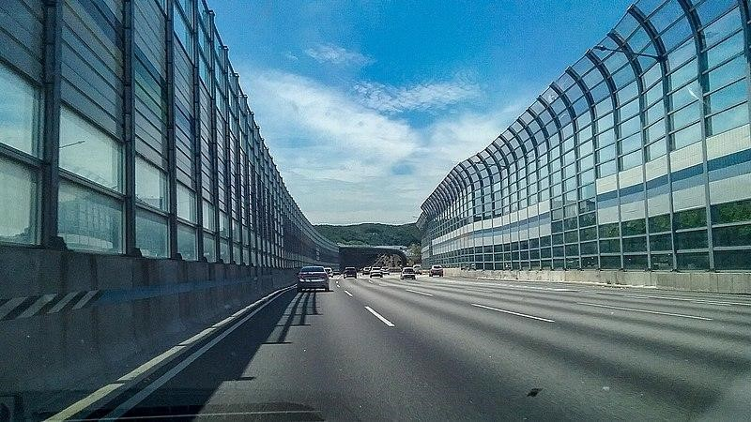

Also known as **noise walls,** these types of measures to block out high intensity traffic noise were first tested in the United States in the 1960s, and also became popular there in the 1970s with environmental laws. Noise does not only affect people, it also creates [serious problems for wildlife..](https://www.science.org/doi/10.1126/science.aah4783)

# NOISE REDUCING ROAD SURFACES

The city of Delft managed to **reduce road traffic noise by 6 dB** thanks to *quiet asphalt.* Studies that the limit for this technology is between 4 and 6 dB although limited, for urban environments it is very useful and considerably more affordable than noise barriers.

# LOWER SPEEDS

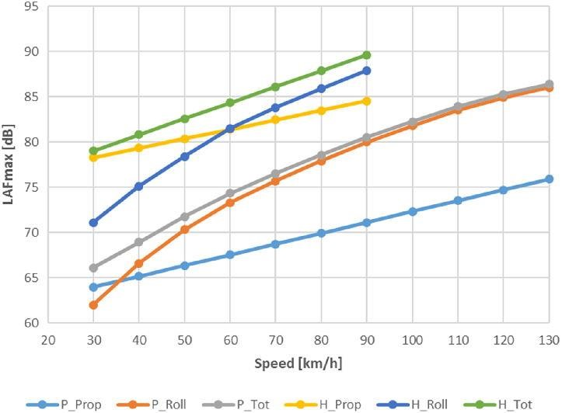

"If you can't remove motorized vehicles, the next best thing is to **reduce their speed**", according to the mobility expert Jason Slaughter in 'Cities Aren't Loud: Cars Are Loud'.

For any type of engine, greater speed means more noise, as shown in the graph. That is why often policies to reduce noise pollution (and [increase road safety)](https://tomorrow.city/a/what-is-the-evolution-use-car-city) consist in **changing infrastructures to reduce speed.** (Signs by themselves [only reduce a couple of km/h.](https://www.roadsafetyknowledgecentre.org.uk/downloads/20mph-reportv1.0-FINAL.pdf)

# ELECTRIC VEHICLES

[More space is also being given to electric vehicles](https://tomorrow.city/a/integrating-electric-vehicle-charging-points-into-the-urban-architecture) which, at low speeds are very quiet, however, given their volume, they can sometimes be noisier than an internal combustion vehicle at high speeds.

# VEGETATION SURROUNDING ROADS

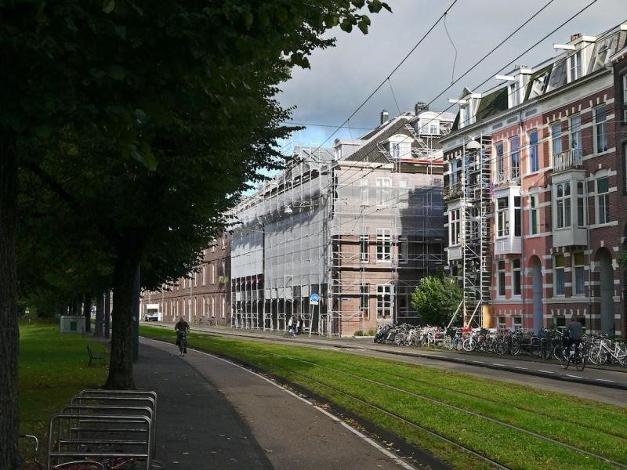

Green borders covered with plants running alongside a road are **clearly a non-tech element,** but incredibly functional. However, studies on the effectiveness of this solution, which is high, are at the forefront of technology. Very often, the best technology we can use is the oldest available to us.

# HIGH-TECH BIKES

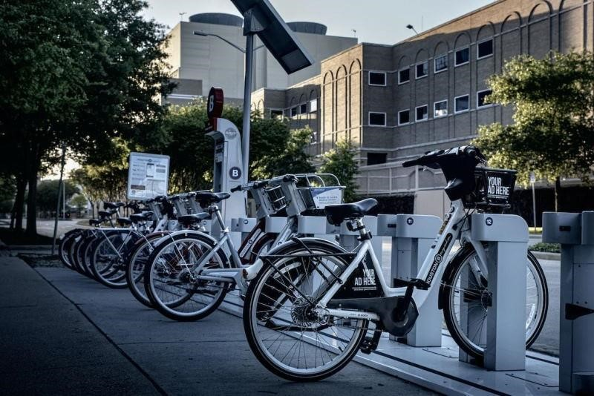

Bikes are not generally considered to be a technological element, but the way in which they are introduced in cities on a sharing basis with electric assistance, in automated docks and digitized with photovoltaic cells that charge with solar panels are high-tech indeed. And they are silent and silencing. It has been proven that bikes reduce average speeds and in turn traffic noise; and this reduces the number of vehicles.

In the urban battle against noise, all these technical, technological and scientific solutions are going to be required in order to reduce the noise thresholds to values that are not harmful to people. The mere presence of people can create noise levels that are high enough to bother residents, therefore part of the technical solutions entails **laws that focus on inappropriate or bothersome behaviors.**